assignment #06

Course: CHE 341: Chemical Process Control
Term: Spring 2026
Professor: Dr. Michael Caracotsios
Office: EIB 244

Cell Phone: (630) 696-0934
E-mail: mcaracot@uic.edu

Name: ______________________________
Due Date: Friday, April 17th TA’s Mailbox

INSTRUCTIONS FOR ASSIGNMENT DELIVERY

- Prepare a typed report of your assignment.
- Include this cover page with your name in the report.
- Upload your report as a PDF file by the Due Date and Time(6:00PM) on the UIC Blackboard.
- Place a hard copy of your report as a PDF file by the Due Date and Time(Closing of the Business Day) in the TA’s mailbox.

- Assignments that are not typed will not be accepted.
- Late Assignments will not be accepted without prior approval.
- You may use the Internet as well as ChatGPT or other public tools as long as you place a written statement about their use in your assignment report

Problem: Two-Tank Level Control System

In many chemical process applications, cascaded tank systems are used to attenuate disturbances and improve level regulation. Consider the two-tank system shown below, where liquid flows from Tank 1 into Tank 2.

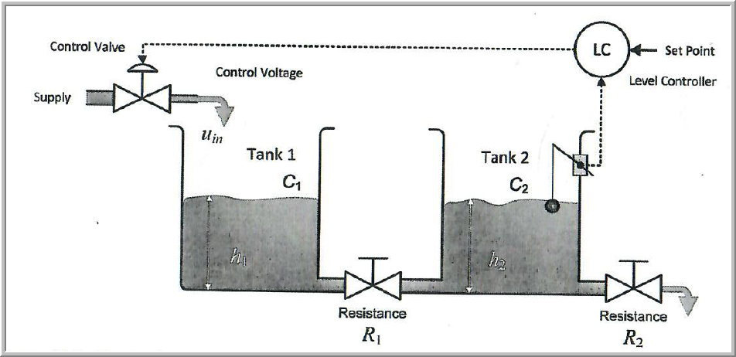

A level transmitter is installed in Tank 2 and provides feedback to a PID controller, which manipulates the inlet flow rate to regulate the level in Tank 2.

The capacitance of the first and second tank is C₁=C₂=1.0 m³/m and the outlet resistances of the first and second tank R₁=0.5 m/(m³/min) and R₂=0.333 m/(m³/min). The volumetric flow rate through the gate valves varies linearly with the pressure drop. Assume that the time delays in the control loop including the transportation lag between the first and second tank amount to around 35% of the dominant time constant of the system.

- Derive the process and disturbance transfer functions assuming that the inlet flow acts as the manipulated variable (MV) and also as the disturbance variable (DV).
- Design a PID controller with GM=3 and PM=60 degrees and perform a simulation for set point and disturbance change of unit size.
- Compare your controller with:
  - Ziegler-Nichols Open Loop
  - Cohen-Coon
  - Ziegler-Nichols Closed Loop
  - Luyben-Tyreus
  - IMC-based tuning
  - Your own design

Present your results in a tabular form and compute the following metrics for both set point tracking and disturbance rejection of unit size.

- Overshoot (if present)
- Settling time
- Gain Margin
- Phase Margin
- Maximum amount of time delay allowed before the onset of instability
- Peak value M_{s} of the sensitivity function
- Peak value M_{t} of the complementary sensitivity function

Include all the simulation graphs in your final report along with the Excel table shown below
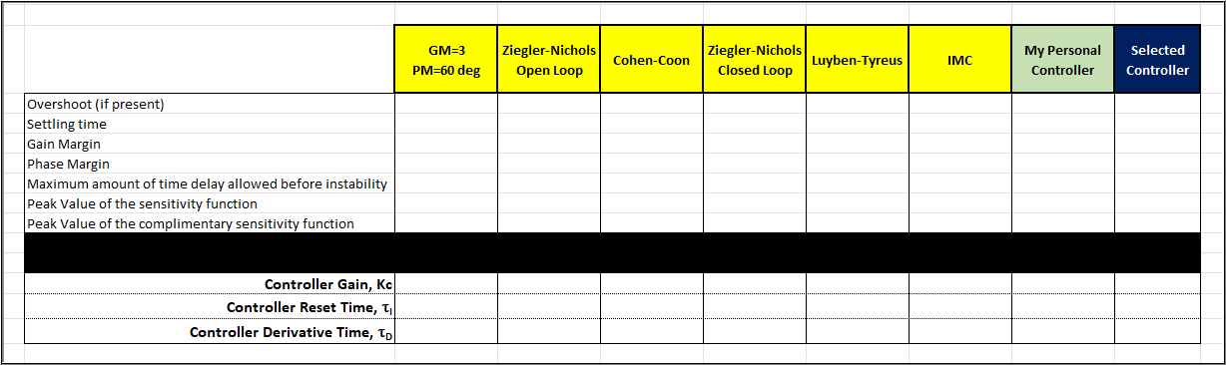

Discuss the trade-offs observed between performance and robustness for the different controllers. Comment on which controller provides the best overall performance and justify your answer.

